2

Building the Social Network: BuddyPress & WP Symposium

# User-Generated Content using TDO Mini Forms

The tutorial in Chapter 2 of the book taught you how to create a user-generated content (UGC) submission form, using a commercial plugin called Gravity Forms. Virtually every aspect of this plugin is superior to the free alternative, TDO Mini Forms, which is no longer supported by its developer. Gravity Forms also supports third-party integration for Campaign Monitor, MailChimp, Freshbooks and PayPal, to name a few services. Nevertheless, if you want to test UGC on your site using TDO Mini Forms, look no further.

How to Get Your Users To Create Original Content For You

Since some of the functionality in Gravity Forms is absent in TDO Mini Forms, we’ll circumvent those roadblocks by creating a slightly different setup for your UGC submission form.

Part 1: Create a Post Content Form with Ratings

This part makes extensive use of IDs, so to make it easier to identify them, we’ll add that functionality by navigating to Add New under Plugins and searching for WP Show IDs. Install and activate the plugin.

Next, navigate to Categories under Posts and create a new category labelled Reviews.

Create five sub-categories, using the Review category from the previous step as a parent category. To create sub-categories, simply select Review from the Parent dropdown selection when you create these next categories. The categories in the order of how you should create them are as follow: Excellent, Very Good, Average, Fair, Poor. Be sure to write down the IDs for the respective categories. (Sub-categories are displayed with a leading dash under the parent category in the category list.)

Since development on TDO Mini Forms is on indefinite hiatus, you can try to download the plugin by navigating to Add New under Plugins in your WordPress Dashboard and then searching for TDO Mini Forms. Install and active the plugin if it’s still in the WordPress repository. Alternatively, you may download a copy of the plug at http://socialmediaforwp.com/downloads/tdo-mini-forms/. Once you’ve downloaded, navigate to Add New under Plugins, press the Upload link below the Install Plugin header, select the downloaded zip file and press the Upload button. Be sure to activate the plugin.

To create the UGC submission form, navigate to Form Creator under TDO Mini Forms and click on the New button located near the top.

You’ll be prompted to provide a Form Name and Form Description under the General tab. Name it something like User Review and enter a descriptive sentence. Be sure that submit new and Posts are selected, so that the options read This form will be used to submit new Posts.

Depending on your preference, you can enable a Preview button, which will let your users preview their submissions before they’re posted. Include on ‘Your Submissions’ page should also be enabled by default, which you can also uncheck, depending on your preference. Uncheck Enable AJAX, as this may conflict with other scripts on your site. Be sure to press the Save button to save your changes.

Under the Access Control tab, check Unregistered Users, so they can submit submissions without registering.

Under the Submitting tab, select Reviews from Step 3 under the dropdown selection for Default Category of new submissions.

Under the Moderation tab, uncheck Enable Moderation so your submissions aren’t queued for approval. Be sure to check Users with publish rights will have their posts automatically published and leave If automatically published, redirect to Published Post unchecked. If you want to be notified of each submission, you can enable this option by checking the appropriate selection under Send Moderation Email Notification to and specifying your email address in the field below. Be sure to press the Save button to save your changes.

Near the top below your form name, click on the Create link to create your form. You will see two columns – one column displays all the options and the adjacent column is your form.

Drag and drop the Content widget from the Available Widgets column into Your Form. Change the label from Content in the Widget Title field to Review. Change the label from Post Title in the Title field to Product or Service. Close the widget and press the Save Changes button below.

Next, drag the Categories widget from the Available Widgets column into Your Form. Title it Rating.

Under the List of categories to include field, enter the IDs from Step 3. Select Checkboxes for the Display categtories as: option. Close the widget and save your changes again.

To create the form submission page, navigate to Add New under Pages, title it Submit Your Review and enter [tdomf_form1] in the content field, where the number indicated your form ID. Since this is the first time you used TDO Mini Forms you will most likely be able to use this shortcode.

Press the Publish button to view and test out your UGC submission page. Upon testing out the form, you should be redirected to your submission, which should also be automatically categorized under Reviews.

TDO Mini Forms might display an error message reading Error: No default author set! Create dummy user for default author automatically ». If this is the case, click on the link, which will create a Default Author for you, and press the Save button to save your changes.

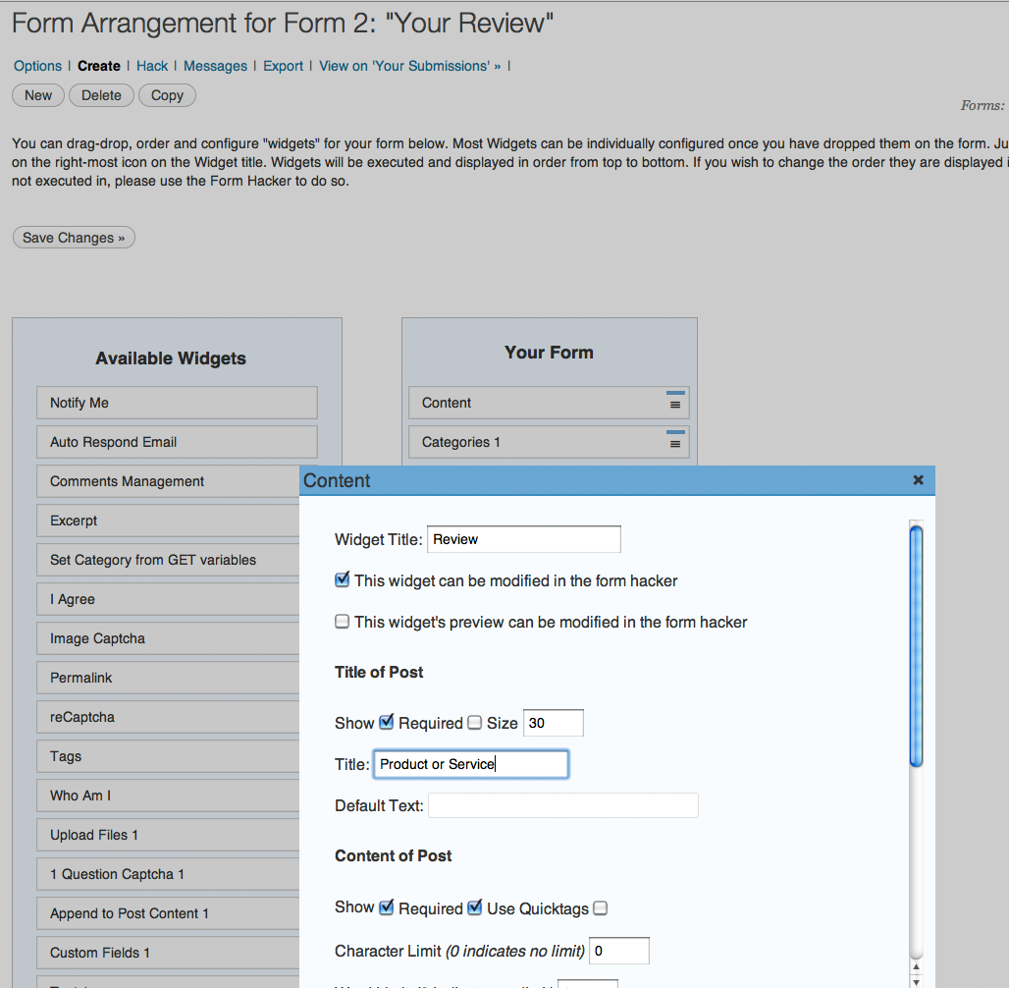

Insert 9805_02_01_TDO-Mini-Forms.png

Part 2: Simplifying the Process of Sharing User Reviews

How to Enable Users to Share Your Content

By now, sharing content using social media icons is common practice. If you visit any publishing site, you will see multiple buttons that make it easier for the reader to share a story. In this case, you’re going to enable authors to share their content easier. The last thing people want to do is clicking on the browser’s address bar, copy the link, start up a new browser session, paste the link somewhere and then send it off to a friend. It’s not what they’re used to, so let’s provide this same functionality found on many other sites to simply this process.

#### Part 2: Simplifying the Process of Sharing User Reviews

1. Since BuddyPress doesn’t ship with automatic sharing capabilities via Facebook, Twitter or any other social network out of the box, we’ll use AddThis instead. If you don’t have a Facebook, Twitter, Google or Open ID account, register for a free AddThis account at http://www.addthis.com, by clicking on the Join Now link in the top right corner.
2. By default, AddThis displays four social media icons of 11 default services, using the most recently used destinations. However, to customize these icons and the URL they should point to, we’ll have to modify the code by using the snippet below, which calls for the Facebook, Twitter, MySpace and e-mail icons.

<div class="addthis_toolbox addthis_default_style addthis_32x32_style" addthis:url="%%SUBMISSIONURL%%" addthis:title="Read my latest review at">

<a class="addthis_button_facebook"></a>

<a class="addthis_button_twitter"></a>

<a class="addthis_button_myspace"></a>

<a class="addthis_button_email"></a>

</div>

<script type="text/javascript" src="http://s7.addthis.com/js/250/addthis_widget.js">

</script>

Insert 9805_02_01-TDO-Mini-Form.txt

More information on AddThis customization can be found at https://www.addthis.com/help/client-api#rendering-preferred-services

1. Back in your WordPress Dashboard, return to the form you created in Part 1 by navigating to Form Hacker under TDO Mini Forms. Click on the Messages link below the form name.
2. Scroll down to the Submission Published section and write a call to action below the existing html, starting on a new line. Something like Share this review using any of the services listed below will suffice. You may want to emphasize it with some CSS formatting. You may further want to edit any of the copy for better feedback. For example, instead of Thank you for using this service, you may want to display Thank you for your submission!
3. On the next line, paste the code from Step 2. Press the Save button to save your changes.
4. Be sure to uncheck comments, trackbacks and pingbacks in the Discussion section, for your UGC submission page.

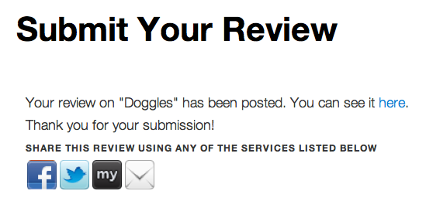

Insert 9805_02_02-TDO-Mini-Form.bmp

You can take this tutorial a step further by integrating Achievements for BuddyPress. For example, you could add one more line of copy that reads Earn 10 points if you share your review on your Activity stream and create a new Achievement for this action.

What just happened?

Upon the posting of the content from Part 1, your users also needed to be able to share it through popular social networking sites like Facebook and Twitter, which was accomplished using the AddThis service. You also modified the AddThis service to use only certain social networking services.